
BADMON FITNESS GYM
P.O Box: 67820-00100,
Nairobi County, Kenya.
Tell: +25475606000
Email: badmongym@gmail.com

Your one-stop gym center

BUSINESS PLAN
PRESENTED BY: LEWIS NZAU SINO
ADMISSION NUMBER: BCSC01/0071/2018

PRESENTED TO: THE CO-OPERATIVE UNIVERSITY OF KENYA (CUK) IN PARTIAL FULFILLMENT OF
THE REQUIREMENTS FOR A DEGREE IN COMPUTER SCIENCE

DATE: JULY, 2021

DECLARATION
I hereby declare that this Project Proposal is my own work and has, to the best of my
knowledge, not been submitted to any other institution of higher learning for any
award.
Name: LEWIS NZAU SINO
Admin. No: BCSC01/0071/2018

Signature………………………………………….…
Date: 26th July 2021

This business plan has been submitted with our approval as university supervisors for a Bachelor’s degree in Computer Science.

Signature…………………………………………………
Date: 5th April 2021
MRS. GRACE OKELLO
Supervisor

ACKNOWLEDGEMENT
I give sincere gratitude to the Almighty God for his sufficient grace, protection, and mercy, for His gift of life thus far. It is because of His love and kindness that I was able to come up with this business plan.
I would like to express my special appreciation to my supervisor, Grace Okello for her assistance and guidance in witting this business plan.
I acknowledge with thanks the overwhelming support I got from my parents. Without their moral and financial support, this write-up would not be successful.
I am greatly appreciative to my classmates and friends who have been the best company and source of social support during this period of writing the business plan.

DEDICATION
I dedicate this business plan to all my family members and friends for their invaluable support, love, and encouragement in the course of writing this business plan.

EXECUTIVE SUMMARY
BADMON FITNESS GYM will be a new fitness center dealing in physical fitness for all interested which will be based in Nairobi town. BADMON FITNESS GYM emphasis will be on conducting practical aerobics in an equipped gym facility. We will also emphasize applying an online community through our built in web & mobile application that will basically extend our services to remote places. Although we intend to start as a small-scale facility, it will not in any way stop us from maximizing our potential in the essential services of sustaining a strong immunity.
BADMON FITNESS GYM will hire highly skilled exercise physician who will educate clients on their best nutrition to undertake with the routine workouts. Every client will be trained by a exercise physician who will be able to coach them on their assigned routine workouts & diet. On consultation time we want our customers to achieve every single step to realizing the importance of a balanced diet. Our location will offer a relaxing atmosphere for customers to enjoy their stay.
We will ensure that we hold ourselves accountable to the highest standards by meeting our customers' needs precisely and completely. We will cultivate a working environment that provides a human, sustainable approach to earning a living, and living in our world, for our employees and our customers. Our employees will be driven by a passion for the services they are offered.
As the founder of the facility, I will oversee all operations of the business and business decisions. I will have the aid of assistant managers, a marketing team, an accountant. We will narrow the population down into age demographics and formulated advisory strategies with each key group to ensure success.

Table of Contents

Table of Contents
DECLARATION 2
ACKNOWLEDGEMENT 3
DEDICATION 3
EXECUTIVE SUMMARY 4
Table of Contents 5
CHAPTER ONE 8
BUSINESS DESCRIPTION 8
1.0 BADMON FITNESS GYM 8
1.1 Business Sponsors 8
1.2 Business Name 8
Nairobi town 8
1.3 Business Location and Address 8
1.4 Form of business ownership 9
1.5 Type of Business 9
1.6 Products and services 9
1.6.1 Products 9
1.6.2 Services 10
1.7 Justification of opportunities 10
1.8 The Industry 10
1.9 Business Goals. 11
1.10 Entry Strategy and Growth strategy 11
1.10.1 Entry Strategy 11
1.10.2 Growth Strategy 11
CHAPTER TWO 12
MARKETING PLAN 12
2.0 Introduction 12
2.1 Customers 12
2.2 Market Share 12
2.2.1 Market Segmentation 12
2.3 Marketing Strategy 14
2.3.1 Pricing Strategy 14
2.3.2 Promotion Strategy 16
2.4 Sales Strategy 16
CHAPTER THREE 17
ORGANIZATION AND MANAGEMENT PLAN 17
3.0 Introduction 17
3.1 Personnel Plan 17
3.2 Duties and Responsibilities 18
3.4 Remunerations and Incentives 18
3.4.1 Incentives 18
3.5 Legal Requirements 18
3.5.1 Licenses 19
3.5.2 Permits 19
3.5.3 Bylaws 19
3.6 Support Services 19
3.7.1 Professionals 20
3.7.2 Institutions 20
Banking 20
Inland transit 20
Third-party liability 21
Political risk 21
Legal Services 21
CHAPTER FOUR 22
PRODUCTION AND OPERATION PLAN 22
4.0 Introduction 22
4.1 Operation facilities and capabilities 22
4.1.1 Capability table 22
4.2 Production strategies 23
4.3 Production Process 23
4.3.1 External Competition 23
4.3.2 Political factors 24
CHAPTER FIVE 25
FINANCIAL PLAN 25
5.0 Introduction 25
5.1 Pre-operational costs 25
5.2 Break-even Analysis 28
5.3 Projected Profit and Loss 30
5.4 Projected Cash Flow 32
5.5 Projected Balance Sheet 34
5.6 Business Ratios 35

CHAPTER ONE

BUSINESS DESCRIPTION

1.0 BADMON FITNESS GYM
The consultancy will be owned by Mr. Lewis, a resident of Nairobi County. Mr. Lewis will have a Degree in Computer Science from the Co-operative University of Kenya. The facility will be on conducting practical aerobics in an equipped gym facility. Since our community have become absorbed by the sedentary lifestyle of the modern world , we need better lifestyle practices.

1.1 Business Sponsors
The business will be established by Mr. Lewis Nzau after foreseeing the lack of proper gym training facilities. The idea came after reading an article that explained we need at least 150 minutes of moderate aerobic activity or 75 minutes of vigorous aerobic activity every week. It was further motivated by the nutrition knowledge that I have obtained in my career.

1.2 Business Name

BADMON FITNESS GYM will be a start-up venture that will be located in Nairobi town

Nairobi town
Email; badmongym@gmail.com
Website: www.badmongym.com

1.3 Business Location and Address
The clinic will be solely owned by Mr. Lewis Nzau. The sole proprietor business will be located in Nairobi town. In a sole proprietorship, the creative direction of the company will be completely at the owner’s direction, and this way he gets the opportunity to see his ideas put into action and result in company success. He also understands in a sole proprietorship, if the company encounters a problem or incurs debt and other obligations, risks losing personal money to settle these issues. Moreover, the personal properties can be at risk if the business fails or if it faces legal actions from disgruntled employees.
The company will be strategically located in the town center and close to residential and commercial business.

1.4 Form of business ownership

BADMON FITNESS GYM will use the advice on proper workouts, physical activity levels, how to balance diet. We will help make meal plans and advice on diet choice .
Inspired by cultures across the country, we will be well versed in understanding various traditional physical prowess so that we can be able to counsel our clients holistically. Every exercise physician will be assigned a client based on ages, regional backgrounds as this will be freshly-prepared for customers meeting their individual dietary needs preferences.

1.5 Type of Business

BADMON FITNESS GYM will be a clinic that will be dealing with the physical fitness, nutrition and wellness of any interest with remote or physical access. Our team of exercise physicians will conduct the workout routines training & offer meal plans and advice on diet choice.

We will also extend the services through online based web & mobile applications. This will ensure that our online presence is felt and catered for those opting a remote service.

1.6 Products and services

1.6.1 Products

BADMON FITNESS GYM will offer Nairobi residence a trendy gym facility and a stable social environment. Will conduct training schedule via the exercise physicians based on a monthly subscription model . The service subscription will be accompanied by regular advice on healthy dishes due to the demand of achieving fitness gains.

BADMON FITNESS GYM will offer gym store that will cater to improving our client’s physical fitness.

The service subscription will also include the online application that extends & gathers information of your fitness activity & an online gym store.

1.6.2 Services

As stated, the online service will be available for the client’s need with a easy user interface. Even placing orders for pick-up and delivery with an estimated wait time and a digital receipt provided. For those customers that prefer to engage in the gym facility center, they can enjoy ambient music as they train. Our atmosphere will make the facility center a place people will enjoy they time.

1.7 Justification of opportunities
The clinic will be located near, Kencom Bus station at Nairobi CBD, this will attract a high number of customers from the neighboring institutions since it's the only fitness center around these institutions. Located in Nairobi since this town has very many companies and institutions with working adults, hence we will have a market for our balanced diets.
Many elderly people working in Nairobi live far from the town hence it will be much convenient for them to visit the online site. The online service will also provide an edge over the market to reach influence over remote regions.

1.8 The Industry
BADMON FITNESS GYM will be under the health ministry. The ministry of health is a parastatal run by the government, it deals with the health and wellness of the government and its citizens. A health unit such as a consultancy clinic, hospital, or a health clinic consists of multiple groups such as facility maintenance and direct operations like dietitians, management, marketing, and human resources, doctors, and nurses.
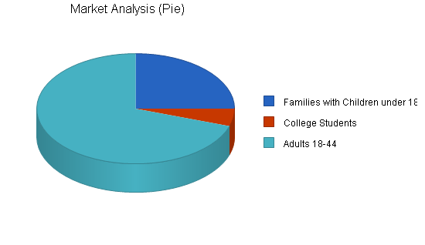
Before structuring as an industry, the historical roots of health were in the western world in the form of health assistance and wellness mainly for Christian pilgrims directed to Rome.

1.9 Business Goals.
The goal will be to provide unique, distinct accurate fitness coaching and experience from environmentally sustainable locations while the employees ensure customers always receive exceptional, consistent service

1.10 Entry Strategy and Growth strategy

1.10.1 Entry Strategy
The strategy will be, to succeed by giving people a combination of relatable, concise training routines with a balanced diet lifestyle tips in an environment that attracts people of its serenity. Our competitive edge will be the cutting edge training equipments with relatable coaching routines & also improvement on their diet.

1.10.2 Growth Strategy
Growth trends will be established when, there will be an increase in the customer base, Increase in overhead expenses i.e., the costs of insurance, equipment, supplies, marketing, and human resource.

CHAPTER TWO

MARKETING PLAN

2.0 Introduction
BADMON FITNESS GYM will be marketed through fliers, social media, websites. This will help target several customers who may come across it while researching from the internet or social media and even those who may have been referred to by a customer who will be satisfied with our services.

2.1 Customers
The clinic has a defined target market client that will be the basis of building the business. The clients will be populated in institutions such as schools, hospitals, and commercial enterprises.

2.2 Market Share
A gym is a destination business, therefore it is realistic to include the greater parts of the city area when looking at potential customers. According to the Kenya. Census report found on www.kenya.gov the greater Nairobi CBD area has a population of 354,669.
When looking at the potential market for a gym in Nairobi, it is important to analyze the number of children in the total population. Gyms make a large portion of their profits from running young teenagers programs. 27% of the town’s population is under the age of 18, which compares favorably to other current gym locations.

2.2.1 Market Segmentation
Customers will be broken into three focused segments consisting of children, college students, and adults 18-44. It is important to note that experienced fit people will not be the focus of marketing for BADMON FITNESS GYM. This is for two primary reasons. First, as the only gym in the area, any person wanting to train inside will naturally gravitate to BADMON FITNESS GYM.
The second reason is that the total population of fit people is quite small compared to the total population of the area.
Children between the ages of five and 18 represent the greatest potential for revenue. The Nairobi CBD area has approximately 70,000 children in this age range. This compares favorably to the nearby CBD areas which are currently able to maintain a successful gym.
College students are another focus group for BADMON FITNESS GYM. This is because they tend to do activities in social groups. By drawing in one college student, he or she will often return with one or more friends on the next visit. Nairobi CBD has two main near colleges. Combined, the college population is at least 15,000.
College segment, in that they are all adults between the ages of 18-44. These are the main patrons of any gym. In Nairobi CBD, there are 134,774 people that fit within this age group.

Market Analysis
Potential Customers | Growth |  |  |  |  |  | CAGR
Families with Children under 18 | 3% | 48,131 | 49,575 | 51,062 | 52,594 | 54,172 | 3.00%
College Students | 1% | 10,000 | 10,100 | 10,201 | 10,303 | 10,406 | 1.00%
Adults 18-44 | 3% | 134,700 | 138,741 | 142,903 | 147,190 | 151,606 | 3.00%
Total | 2.90% | 192,831 | 198,416 | 204,166 | 210,087 | 216,184 | 2.90%

2.3 Marketing Strategy
BADMON FITNESS GYM plans on leveraging its unique position as the only gym in Nairobi CBD to gain early positive PR. In addition, BADMON FITNESS GYM will capitalize on word of mouth to gain new clients. Occasionally a print ad will be bought in the local paper. Literature will be passed out at local schools emphasizing the ability to enjoy cutting edge gym facility. Staff members will volunteer at local charities, in order to build strong relationships in the community. BADMON FITNESS GYM will also build community awareness by being present at local events, such as giving training to local schools.

2.3.1 Pricing Strategy
BADMON FITNESS GYM’s initial pricing strategy will be based on gyms in other similar markets. This makes the most sense, because after the initial start-up costs gyms have extremely low cost of sales. By using other gyms as benchmarks for pricing, BADMON FITNESS GYM can benefit from the the learning curve of others.
Group pricing will begin at Ksh 10000 for up to six people and Ksh1500 for each additional person. In addition, each group will have the option of paying Ksh 3000 to have an employee spend the entire two hours rental session with them.
Individuals will pay an entrance fee with an additional fee to rent equipment. The following are prices with the total price with equipment rental in parentheses:
  - Day Pass- Ksh 1200 (Ksh 1600)
  - 10-Visit Punch card- Ksh 8900 (Ksh 12000)
  - One-Month Membership - Ksh 5500 (Ksh 7000)
  - One-Month College Membership- Ksh 3900 (Ksh 5500)
  - Three-Month Membership-Ksh 13500 (Ksh 16500)
  - Annual Membership- Ksh 38500 (Ksh 43500)
  - College Annual Membership- Ksh 32500 (Ksh 38500)
  - Annual Pay Plan- Ksh 3900/month (Ksh 4900) 12 month minimum contract
  - Family Annual- Ksh 62500 first two Ksh 15000 each additional (Ksh 72500 and Ksh 18000)
  - Family Annual Pay Plan- Ksh 7000 first two Ksh 1500 each additional (Ksh 8000 and Ksh 2000)

Introductory classes will be Ksh 4500 and include a week’s membership with equipment rental. Advanced classes will be offered for Ksh 4500, but will not include the free week. Those only wanting a quick belay lesson will be charged Ksh 1200.
Children’s classes will be offered Monday through Friday. One class a week for children 7-10 years old will be Ksh 6000 for four consecutive weeks. One class a week for children 11-15 will be Ksh 22500 for three months, and the price will include equipment rental as well as a three month pass to come into the gym during normal business hours.

2.3.2 Promotion Strategy
A gym’s membership growth depends on good word of mouth. This is why groups are vital to the success of a gym, because they bring in people that would not normally try fitness.
The key to the success of a gym lies in the fact that fitness is both addictive and more fun when done with others. This creates a situation where one member will bring in many other people to try the sport. This leads to new members who in turn bring more people in to try it.
In addition to word of mouth, BADMON FITNESS GYM will take advantage of its position as the only gym in the Nairobi CBD area to gain access to free press. Television, radio, and print media are constantly looking for new and exciting subjects to bring to their customers. The gym’s uniqueness can be leveraged to create opportunities for press events.
It is also important to approach schools, churches, and scouting groups to educate them on the possibilities of bringing groups to the gym. By showing them the advantages of having field trips and group outings at the gym, many children will be given the opportunity to pursue fitness. This will lead to more group & individual memberships.

2.4 Sales Strategy
BADMON FITNESS GYM will pursue three types of revenue streams: Groups, individual members, and classes.
Groups will include church youth groups, and corporate team building. By being the only gym in the CBD area, BADMON FITNESS GYM offers each one of these groups a unique venue in which to meet. Trained staff will ensure that groups are properly outfitted and trained in order to fully enjoy their time at the gym. By providing a safe and fun time to customers, BADMON FITNESS GYM will be able to grow business exponentially as individual group members decide to bring other groups to the gym. This is also an excellent way of driving individual membership sales.
Not every person has the same financial resources. In order to accommodate the most people, different forms of memberships will be offered. These will include day passes, punch cards, one month, three month, annual, family, and college memberships. In addition, annual memberships will be sold on a monthly installment plan with a signed Electronic Funds Transfer (EFT) agreement.
Classes will be offered to those wanting to gain new skills and, more importantly, for young adults wanting to be part of a weekly group.
Customer service and providing a unique experience will be the hallmarks of BADMON FITNESS GYM.

CHAPTER THREE

ORGANIZATION AND MANAGEMENT PLAN

3.0 Introduction
BADMON FITNESS GYM will use a combination of paid hourly staff and volunteers. A head manager will use his/her extensive experience in the gym industry to manage the day to day affairs of BADMON FITNESS GYM. In addition, we will hire four part-time, hourly staff members. Volunteers will be used to offset needs in route setting, youth programs, and groups.
The climbing gym industry enjoys a high rate of qualified applicants and volunteers. Potential employees are drawn by the lifestyle and atmosphere of gyms. They also enjoy the added bonus of being able to pro deal equipment at a significant discount. This allows gyms to keep employees happy without having to pay high wages.

3.1 Personnel Plan

Forecasted personnel expenditures are based on the total hours worked each month by the manager and the front desk/instructor employees. Salaries for BADMON FITNESS GYM employees will be Ksh 1500/hr for the manager, and Ksh 1000/hr for the instructor/instructors.
Business hours for BADMON FITNESS GYM will be noon-10 PM Monday-Friday, and noon-6 PM on Saturday and Sunday. In addition, employees will work during non-operating hours in order to route set, clean, do general maintenance, and supervise group rentals.
During a normal business week, a total of 40 hrs will be scheduled for the manager and 91.5 hours combined for the front desk/exercise physician .

3.2 Duties and Responsibilities
The table below shows the different positions of workers and their qualifications for the job

Personnel Plan
Manager | Ksh 31,450 | Ksh 34,320 | Ksh 36,610
Front Desk/ exercise physician | Ksh 47,600 | Ksh 52,300 | Ksh 53,000
Total People | 5 | 5 | 5
Total Payroll | Ksh 79,050 | Ksh 86,620 | Ksh 89,610

3.4 Remunerations and Incentives
This includes the salaries the employees will be receiving and also their allowances and any bonus that they are going to receive. An overtime allowance at the rate of 0.01% per hour will be given based on the basic salary.

3.4.1 Incentives
Bonuses will be in form of profit sharing. The company will provide a pool of funds based on a percentage of its annual pre-tax profit. An employee receives a portion of this pool according to their salary. Holiday bonuses will also be provided ranging from small gifts.

3.5 Legal Requirements
The first step will involve registering the Company at the registrar of companies located at Sheria House.

3.5.1 Licenses
After the name searches and filling in the required forms, the Company will be registered and you will be issued with a certificate of incorporation or a business name.

3.5.2 Permits
For us to legally operate as a consultant clinic, we will need to have a health-related permit, this will require a health and medical inspector to visit our clinic and certify it.

3.5.3 Bylaws
A Clearance certificate for fire prevention inspection will be also required. Failure in obtaining it the Company opens to prosecution under building control legislation.
Upon filing our tax returns, the business will also be issued with a tax compliance certificate
LICENSE | PROVIDER | AMOUNT
Tax | KRA | 75,000 per year
Business Permit | Nairobi County | 25,000 per year
Insurance | AON | 60,000 per year
Health Permit | Nairobi County Health  Inspector
Fire Safety Compliance  Certificate | Nairobi Bay County Fire Inspector | 3,000
Registrar of Companies | National Government | 2,000
Health Certificate | H/B County Government | 7,000
Food and Safety Certificate | H/B County Government | 3,000

3.6 Support Services
Support services are those function of organization which does not generate main business. Support services provide internal support to the main business of the organization.

3.7.1 Professionals
These include investors who have decided to invest in our business so that they may benefit.

3.7.2 Institutions

Banking
The business banking services will be done via
Co-operative Bank of Kenya
Nairobi Branch
Account Number: 5541584594
Account Name; BADMON FITNESS GYM
It will be a savings account as the Clinic will be trying to save the earnings from the business for the expansion of the business and tax payments. Co-operative Bank was decided on as the Banks interest rates are attractive in comparison to others
Insurance Services
The Company will turn to AON for its insurance services. It will cover:
Contract work insurance
This covers against physical loss or damages in the restaurant.

Inland transit
This policy covers against loss or damage to the goods/materials while on transit by road and will be provided on a risk basis.

Third-party liability
This covers third-party liability risk in respect to bodily harm and property damage that may occur in the restaurant.
Beneficial occupation
This policy extends to cover fire and burglary damage to property.

Political risk
This extension protects the project against damage/destruction of physical assets, loss of business, or business interruption due to any politically motivated violence.

Legal Services
The Company will look to hire the services of Murgor and Murgor Advocates from time. The Company believes that the law firm will be experienced, somewhat familiar with the industry and its legal environment.
The advocates should be able to:
- Consult and handle all corporate legal processes (e.g., intellectual property, mergers & acquisitions, financial / securities offerings, compliance issues, transactions, agreements, lawsuits, and patents)
- Develop company policy and position on legal issues
- Research, anticipate and guard company against legal risks
- Represent the company in legal proceedings (administrative boards, court trials)
- Responsible for analyzing legal documents on behalf of the company

CHAPTER FOUR

PRODUCTION AND OPERATION PLAN

4.0 Introduction
Each hired employee will have the tools and equipment required to work efficiently. New tools will be replaced after 6 months depending on how efficient the tool will be to ensure efficiency in their work, this will ensure that the business saves on time when serving customers.

4.1 Operation facilities and capabilities
BADMON FITNESS GYM in its quest to provide its clients with fitness services will need the following machinery and equipment:

4.1.1 Capability table

Requirements
Start-up Expenses
Legal | Ksh 300,000
Stationery etc. | Ksh 50,000
Insurance | Ksh 330,000
Rent | Ksh 132,000
Computer | Ksh 100,000
Construction Equipment Rental | Ksh 300,000
Other | Ksh 100,000
Total Start-up Expenses | Ksh 2,500,000
 | \
Start-up Assets
Cash Required | Ksh 2,300,000
Other Current Assets | Ksh 200,000
Long-term Assets | Ksh 9,000,000
Total Assets | Ksh 1,150,000
Total Requirements | Ksh 1,400,000

4.2 Production strategies
BADMON FITNESS GYM will offer fitness training & balanced diet advice plan and how the clients can fulfill them. The train will appeal to any age group interested.
The gym will be open seven days a week from 8:00 AM – 7:00 PM, depending on the gym's success the hours of operation are subject to change. We will be closed for major holidays like New Year’s Day and Christmas.
Special invitations and announcements will be distributed for the opening day, and other special events we host, both personally and over the popular social networking websites such as Facebook and Twitter.
To show customers that their opinions matter, we will be asking them to vote on the advisory personnel in our gym they prefer and those they dislike in the opening weeks. This will allow us to establish a solid advisory schedule that will be appealing to every customer stepping foot in the gym.

4.3 Production Process
The Company believes the following factors will influence its production

4.3.1 External Competition
The gym faces stiff competition from already established similar clinics.

4.3.2 Political factors
Affect production positively or negatively. Decisions about taxation, investment, or fiscal. Policies of Govt. influence production.
The character of people The Company feels that hard workers and sincere workers always produce more and hence it will very important.

CHAPTER FIVE

FINANCIAL PLAN

5.0 Introduction
BADMON FITNESS GYM sales are projected to grow at a conservative rate of 8% per year. The current gym’s size can sustain this rate for at least 10 years.
After start-up, BADMON FITNESS GYM may look to create more opportunities for growth by opening a fitness gear retail shop or small coffee shop within its premises. Funding for this and other possible expansions will be done through loans to the owners. .

5.1 Pre-operational costs
I plan on personally funding the entire start-up cost. The initial investments of Ksh 14,000,000 will come from taking out second mortgages on their houses and supplementing this amount from personal saving accounts.

Start-up Funding
Start-up Expenses to Fund | Ksh 2,500,000
Start-up Assets to Fund | Ksh 11,500,000
Total Funding Required | Ksh 14,000,000
Assets
Non-cash Assets from Start-up | Ksh 9,200,000
Cash Requirements from Start-up | Ksh 2,300,000
Additional Cash Raised | Ksh 0
Cash Balance on Starting Date | 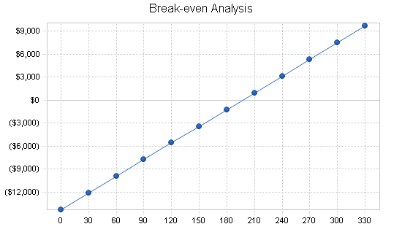  Ksh 2,300,000
Total Assets | Ksh 11,500,000
Liabilities and Capital
Liabilities
Current Borrowing | Ksh 0
Long-term Liabilities | Ksh 0
Other Current Liabilities (interest-free) | Ksh 0
Total Liabilities | Ksh 0
Capital
Planned Investment
Lewis Nzau | Ksh 14,000,000
Additional Investment Requirement | Ksh 0
Total Planned Investment | Ksh 14,000,000
Loss at Start-up (Start-up Expenses) | (Ksh 2,500,000)
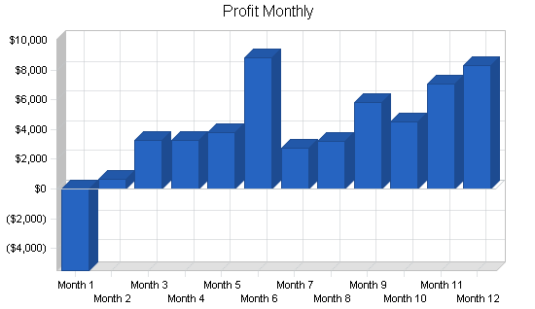  Total Capital | Ksh 11,500,000
Total Capital and Liabilities | Ksh 11,500,000
Total Funding | Ksh 14,000,000

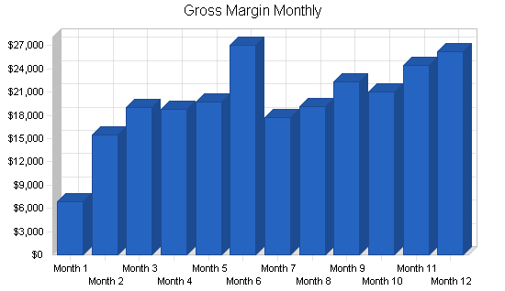
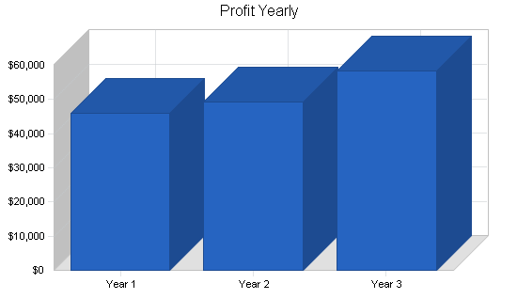
5.2 Break-even Analysis

Our monthly Break-even point is shown below. With extremely low variable costs, the primary monthly expense comes from fixed costs.

Break-even Analysis
Monthly Units Break-even | 197
Monthly Revenue Break-even | Ksh 1,500,095
Assumptions:
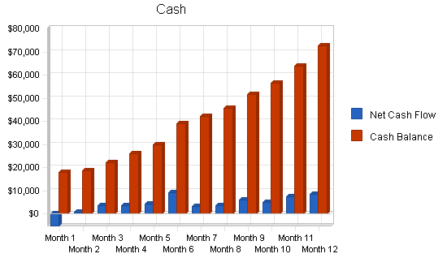  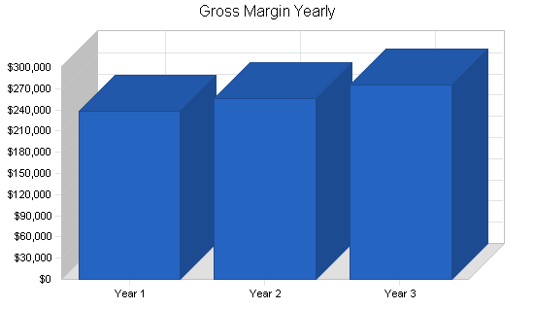  Average Per-Unit Revenue | Ksh 7,600.63
Average Per-Unit Variable Cost | Ksh 300.84
Estimated Monthly Fixed Cost | Ksh 1,400,338

5.3 Projected Profit and Loss
In the first year of business, BADMON FITNESS GYM will see an initial strong growth in sales followed by a slow, steady growth. The sales spike in January is due to the increased focus on fitness that traditionally happens during this month. Summers tend to be slower months for memberships; however, School holiday long breaks will make up for this loss in revenue.

Gyms are expensive to start, but the cost of sales is very low. Due to the following reasons general operating expenses for a climbing gym are also low:

- Less than prime real estate is needed for site
- Staffing needs per customer are very low and volunteers are readily available
- High word-of-mouth marketing leads to less paid marketing
- Equipment and climbing walls have long lifespans

All of these factors combine to make it realistic that BADMON FITNESS GYM will be profitable in its first year of business.

5.4 Projected Cash Flow
As seen in the following chart, BADMON FITNESS GYM will enjoy a strong positive cash flow following its first month of operation. This is due to the fact that there is no need to purchase goods. It is also important to note that BADMON FITNESS GYM will have no need to give its members terms, and therefore, all payments will be made by cash, check, credit card, or EFT.

Pro Forma Cash Flow
Cash Received
Cash from Operations
Cash Sales | Ksh 25403200 | Ksh 27329600 | Ksh 29493900
Subtotal Cash from Operations | Ksh 25403200 | Ksh 27329600 | Ksh 29493900
Additional Cash Received
Sales Tax, VAT, HST/GST Received | Ksh 0 | Ksh 0 | Ksh 0
New Current Borrowing | Ksh 0 | Ksh 0 | Ksh 0
New Other Liabilities (interest-free) | Ksh 0 | Ksh 0 | Ksh 0
New Long-term Liabilities | Ksh 0 | Ksh 0 | Ksh 0
Sales of Other Current Assets | Ksh 0 | Ksh 0 | Ksh 0
Sales of Long-term Assets | Ksh 0 | Ksh 0 | Ksh 0
New Investment Received | Ksh 0 | Ksh 0 | Ksh 0
Subtotal Cash Received | Ksh 25403200 | Ksh 27329600 | Ksh 29493900
Expenditures | Year 1 | Year 2 | Year 3
Expenditures from Operations
Cash Spending | Ksh 20449000 | Ksh 22036900 | Ksh 23286900
Subtotal Spent on Operations | Ksh 20449000 | Ksh 22036900 | Ksh 23286900
Additional Cash Spent
Sales Tax, VAT, HST/GST Paid Out | Ksh 0 | Ksh 0 | Ksh 0
Principal Repayment of Current Borrowing | Ksh 0 | Ksh 0 | Ksh 0
Other Liabilities Principal Repayment | Ksh 0 | Ksh 0 | Ksh 0
Long-term Liabilities Principal Repayment | Ksh 0 | Ksh 0 | Ksh 0
Purchase Other Current Assets | Ksh 0 | Ksh 0 | Ksh 0
Purchase Long-term Assets | Ksh 0 | Ksh 0 | Ksh 0
Dividends | Ksh 0 | Ksh 0 | Ksh 0
Subtotal Cash Spent | Ksh 20449000 | Ksh 22036900 | Ksh 23286900
Net Cash Flow | Ksh 4954200 | Ksh 5292700 | Ksh 6207000
Cash Balance | Ksh 7254200 | Ksh 12546900 | Ksh 18753800

5.5 Projected Balance Sheet
The balance sheet shows the healthy growth of BADMON FITNESS GYM’s net worth, and its strong financial position.

Pro Forma Balance Sheet
Assets
Current Assets
Cash | Ksh 7254200 | Ksh 12546900 | Ksh 18753800
Other Current Assets | Ksh 200000 | Ksh 200000 | Ksh 200000
Total Current Assets | Ksh 7454200 | Ksh 12746900 | Ksh 18953800
Long-term Assets
Long-term Assets | Ksh 9000000 | Ksh 9000000 | Ksh 9000000
Accumulated Depreciation | Ksh 360000 | Ksh 720000 | Ksh 1080000
Total Long-term Assets | Ksh 8640000 | Ksh 8280000 | Ksh 7920000
Total Assets | Ksh 16094200 | Ksh 21026900 | Ksh 26873800
Liabilities and Capital | Year 1 | Year 2 | Year 3
Current Liabilities
Current Borrowing | Ksh 0 | Ksh 0 | Ksh 0
Other Current Liabilities | Ksh 0 | Ksh 0 | Ksh 0
Subtotal Current Liabilities | Ksh 0 | Ksh 0 | Ksh 0
Long-term Liabilities | Ksh 0 | Ksh 0 | Ksh 0
Total Liabilities | Ksh 0 | Ksh 0 | Ksh 0
Paid-in Capital | Ksh 14000000 | Ksh 14000000 | Ksh 14000000
Retained Earnings | (Ksh 2500000) | Ksh 2094200 | Ksh 7026900
Earnings | Ksh 4594200 | Ksh 4932700 | Ksh 5847000
Total Capital | Ksh 16094200 | Ksh 21026900 | Ksh 26873800
Total Liabilities and Capital | Ksh 16094200 | Ksh 21026900 | Ksh 26873800
Net Worth | Ksh 16094200 | Ksh 21026900 | Ksh 26873800

5.6 Business Ratios
The following table outlines some of the more important ratios from the Athletic Clubs and Gymnasiums, Membership industry. The final column, Industry Profile, details specific ratios based on the industry as it is classified.

Ratio Analysis
Sales Growth | 0.00% | 7.58% | 7.92% | 10.91%
Percent of Total Assets
Other Current Assets | 1.24% | 0.95% | 0.74% | 29.68%
Total Current Assets | 46.32% | 60.62% | 70.53% | 39.03%
Long-term Assets | 53.68% | 39.38% | 29.47% | 60.97%
Total Assets | 100.00% | 100.00% | 100.00% | 100.00%
Current Liabilities | 0.00% | 0.00% | 0.00% | 24.30%
Long-term Liabilities | 0.00% | 0.00% | 0.00% | 23.97%
Total Liabilities | 0.00% | 0.00% | 0.00% | 48.27%
Net Worth | 100.00% | 100.00% | 100.00% | 51.73%
Percent of Sales
Sales | 100.00% | 100.00% | 100.00% | 100.00%
Gross Margin | 93.57% | 93.45% | 93.35% | 100.00%
Selling, General & Administrative Expenses | 75.48% | 75.40% | 73.53% | 71.17%
Advertising Expenses | 0.00% | 0.00% | 0.00% | 2.77%
Profit Before Interest and Taxes | 25.84% | 25.78% | 28.32% | 2.47%
Main Ratios
Current | 0.00 | 0.00 | 0.00 | 1.04
Quick | 0.00 | 0.00 | 0.00 | 0.71
Total Debt to Total Assets | 0.00% | 0.00% | 0.00% | 62.60%
Pre-tax Return on Net Worth | 40.78% | 33.51% | 31.08% | 3.34%
Pre-tax Return on Assets | 40.78% | 33.51% | 31.08% | 8.94%
Additional Ratios | Year 1 | Year 2 | Year 3
Net Profit Margin | 18.08% | 18.05% | 19.82% | n.a
Return on Equity | 28.55% | 23.46% | 21.76% | n.a
Activity Ratios
Accounts Payable Turnover | 8.87 | 12.17 | 12.17 | n.a
Total Asset Turnover | 1.58 | 1.30 | 1.10 | n.a
Debt Ratios
Debt to Net Worth | 0.00 | 0.00 | 0.00 | n.a
Current Liab. to Liab. | 0.00 | 0.00 | 0.00 | n.a
Liquidity Ratios
Net Working Capital | Ksh 7454200 | Ksh 12746900 | Ksh 18953800 | n.a
Interest Coverage | 0.00 | 0.00 | 0.00 | n.a
Additional Ratios
Assets to Sales | 0.63 | 0.77 | 0.91 | n.a
Current Debt/Total Assets | 0% | 0% | 0% | n.a
Acid Test | 0.00 | 0.00 | 0.00 | n.a
Sales/Net Worth | 1.58 | 1.30 | 1.10 | n.a
Dividend Payout | 0.00 | 0.00 | 0.00 | n.a

